Digital timer

Thinkercad simulation & arduino

programming

project overview:
This project demonstrates a digital timer bulid and test in tinkercar , programmed on arduino.
1.Objectives:
- Design and simulate the circuit in thinkercar using identified components.
- Program the arduino to control by the display connection .
Test , and analyze the behavior under different condition.
2.Introduction:
The digital timer is words easily in everywhere . this is in medium size so very to take anywhere,by the basic ideas and easy way of model to prepare the digital timer.
3.Block diagram :
Overall system flow in shown below:
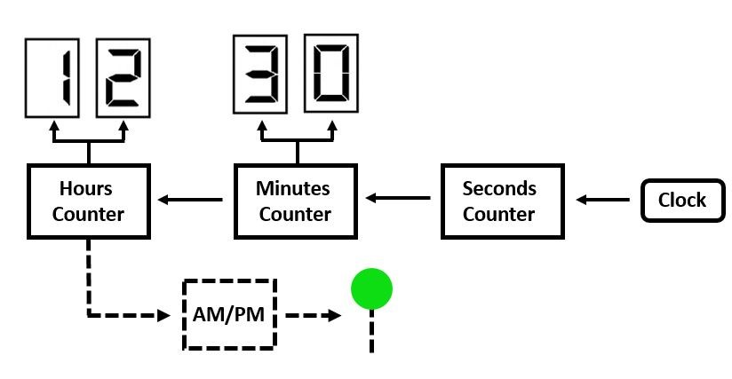
4.components:
components | purpose
1. Arduino Uno R3 | Use to control the display connection
2. MCP23008-based, 32 (0x20) LCD 16 x 2 (I2C) | Use to gave the working connection by the correct connection

5.writing & pin Diagram:
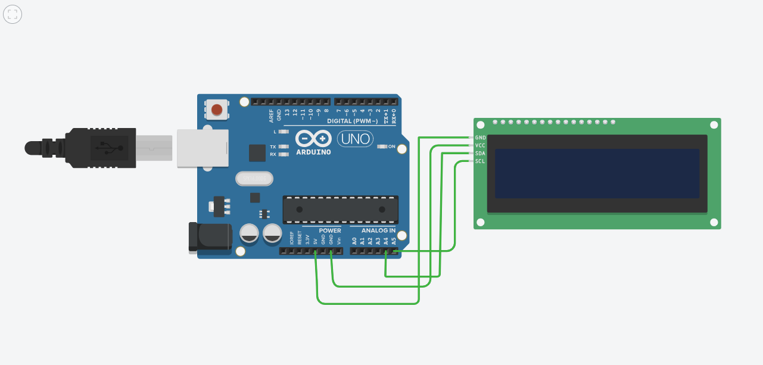

Ardino pin | Display pin
1.A5 | SCL
2.A4 | SDA
3.GND | VCC
4.5V | GND

6.Building Circuits in thinkercad:
1. create a new Tinkercad circuit diagram.
2.Place a Arduino. Uno R3 and display in a correct position .
3.Connect a wire in a correct connection.
4.Check the output of the prepared model .
5.The model now works correctly and perfectly .
6.Check the working connection by using thinkercad.

7.Arduino code:
#include <LiquidCrystal_I2C.h>
LiquidCrystal_I2C lcd(32, 16, 2);
int hour = 12;
int min = 0;
int sec = 0;
String ap = "A";
void setup(){
lcd.begin(16,2);
lcd.init();
lcd.backlight();
}

void loop() {
if(hour == 12 && min ==0&& sec==0){
if(ap== "P"){
ap = "A";
}else{
ap = "P";
}
}
if(sec == 59){
sec = 0;
if(min == 59){
min = 0;
hour++;
}else{
min++;
}
}else{
sec++;
}
lcd.setCursor(0,0);
lcd.print(" 18/12/2025 ");
lcd.setCursor(3,1);
if(hour<10){
lcd.print("0");
}
lcd.print(hour);
lcd.print(":");
lcd.setCursor(6,1);
if(min<10){
lcd.print("0");
}
lcd.print(min);
lcd.print(":");
lcd.setCursor(9,1);
if(sec<10){
lcd.print("0");
}
lcd.print(sec);
lcd.setCursor(11,1);
lcd.print(ap + "M");

}

8.Code explanation:
import tkinter : Imports the Tkinter library, which is Python's standard GUI toolkit, used to create the window and display elements.
- from time import strftime: Imports the strftime function from the time module. This function formats the current system time into a readable string.
- def update_time():: This function gets the current time using strftime and updates the text of the clock_label widget.
  - '%I:%M:%S %p' specifies the 12-hour format (Hour:Minute:Second AM/PM).
  - clock_label.config(text=current_time) changes the text displayed on the label.
  - clock_label.after(1000, update_time) is crucial; it tells Tkinter to call the update_time function again after 1000 milliseconds (1 second), creating a continuous loop that updates the time.
- root = tk.Tk(): Initializes the main application window.
- root.title(...), root.geometry(...): Sets the title and initial size of the window.
- clock_label = tk.Label(...): Creates a label widget where the time will be displayed. You can customize the font, background, and foreground (text color).
- clock_label.pack(...): Organizes and places the label within the main window.
- root.mainloop(): This method runs the Tkinter event loop, which listens for events (like time updates) and keeps the window open until it is closed by the user.

9.Testing & debugging in tinkercad:
1. the important and basic problem is if the wire connection is change means the devices is not work.
2. if the connection of SDA in (display) is change the wire connection position means then the display is on but inside the work is not done .
3. balance wire connection are change the position means the devices is not work

10.what-if testing & behavior analysis:
1. to solve the problem fix the wire connection correctly .
2. fix the arrangement correctly .
3. check the quality of the components properly.
4. If one wire connection also wrong means total device is not work.

11.obersavation:
Through our observation the timer is when not work means the connection between the ardiuno and display is not fis in the correct postion means the problem is form so check the wire connection properly to work again perfectly.
12.Link:
https://www.tinkercad.com/things/h9vKL2CFBKw-copy-of-rtc?sharecode=i3TUuAi61_4A7ynAev4J3lxKXeUIGUFI2d6SXro5VAs

